

iFi Bridge (**Windows** Only)

Setup Guide

## Introduction:

This guide will show you how to setup the iFi Bridge to allow for MQA and Gapless over a network on Roon.

## Step 1:

Firstly, right click on the downloaded ‘iFi-Bridge.zip’ and press ‘**Open**’.

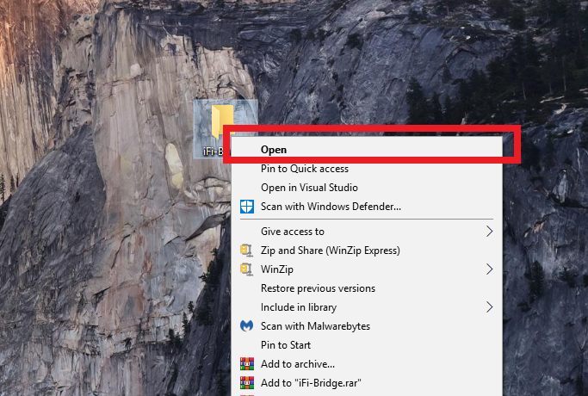

A window will open, in the top right press ‘Extract All’.

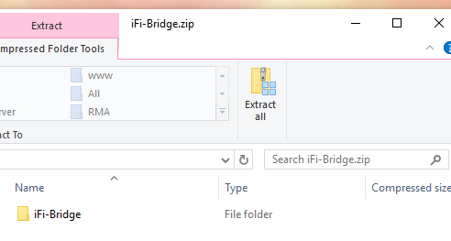

By default, the files will be extracted to the desktop. Press ‘**Extract’**.

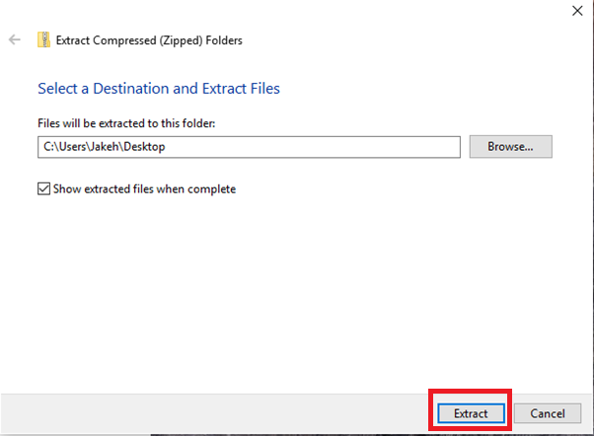

## Step 2:

Secondly, ensure that your Pro iDSD is:

* Connected to your network, either by Ethernet cable or over Wi-Fi (using the Muzo App).
* On ‘App mode’ for input.
* On the ‘Bit perfect’ filter.
* Has the latest firmware. (<https://ifi-audio.com/downloads/> - Please see the ‘Pro iDSD Firmware’ tab)

Please see the user manual below for instructions on how to operate the Pro iDSD.

<http://ifi-audio.com/wp-content/uploads/2019/05/Pro-iDSD-User-Manual-Ver1.6.pdf>

## Step 3:

Locate your ‘iFi Bridge’ folder and open **‘iFi-Bridge.exe’**, this will bring up a pop-up window for operating the iFi Bridge.

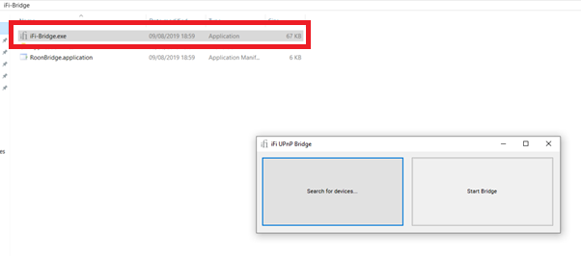

## Step 4:

Press ‘Search for devices’, this may bring up a firewall alert – press ‘Allow Access’.

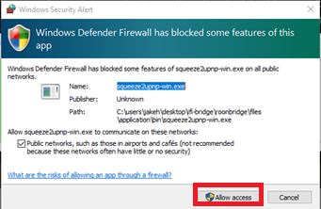

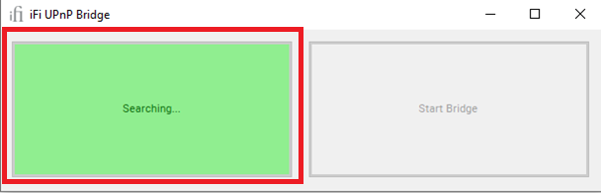

## Step 5:

After searching for devices for 15-20 seconds, a pop-up window will appear saying whether it found devices on your network or not.

If it does NOT, please see **troubleshooting** at the bottom of this page.

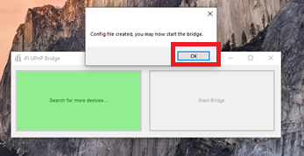

## Step 6:

If successful and it found your Pro iDSD then press ‘Start Bridge’.

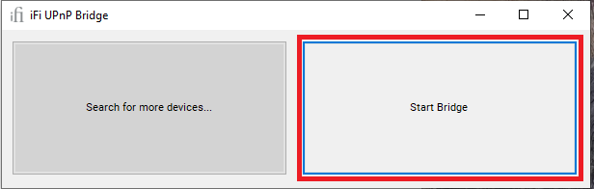

## Step 7:

Open Roon. Go to **Settings > Setup** and Enable ‘Squeezebox Support’.

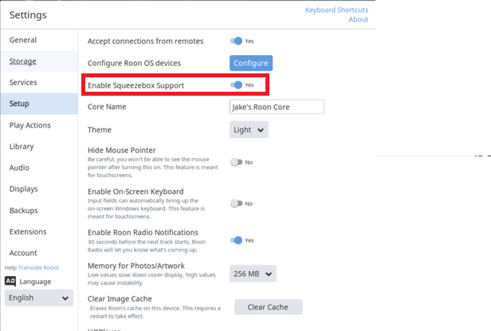

## Step 8:

Next go to **Roon Settings > Audio** to view your available outputs (zones). A ‘Squeeze lite device’ should show up under the ‘Networked’ tab. Rename these to avoid confusion.

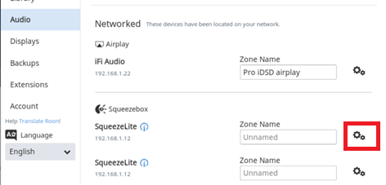

## Step 9:

Press the Settings cog next to the Squeeze Lite device and go to ‘Device Setup’ and select ‘Decoder and Renderer’ under ‘MQA Abilities’.

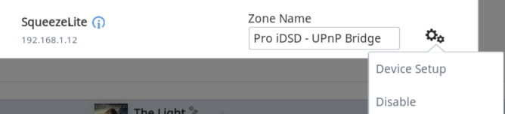

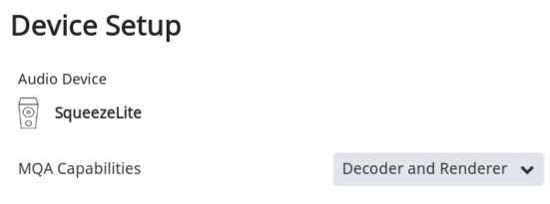

## Step 10:

To play, click the device manager in the bottom right and select your ‘Zone’ and then choose an MQA track. ‘MQA’ should be shown on the front display of the Pro iDSD.

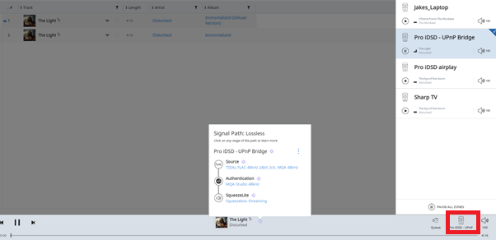

## Troubleshooting:

If you have any issues setting up the ‘iFi Bridge’ do not hesitate to open a ticket on the support system below and we will help you.

<http://support.ifi-audio.com/open.php>

## Cannot find any devices

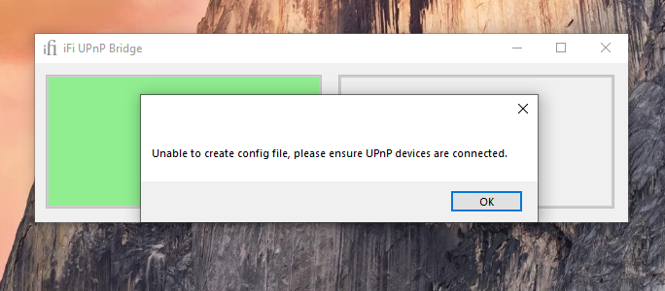

If it did not find any devices, then you will have to double check that your Pro iDSD is connected to the network. You can do this by typing ‘View network computers and devices’ on Windows search and opening it:

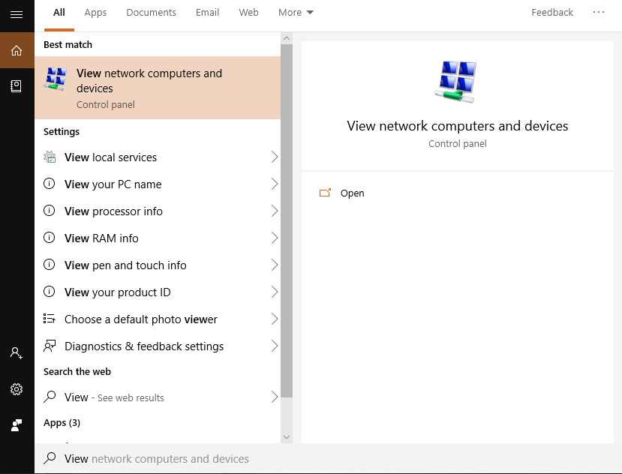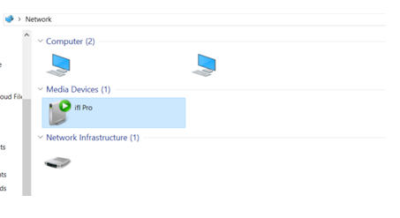

This will bring up all devices connected to the Network. If your Pro iDSD does not show up, then it is not connected to the network.